**4-20mA to 0-5V Converter Rev. A**

**Connection diagramm for 2-wire transducers :**

4-20mA out

Voltage in

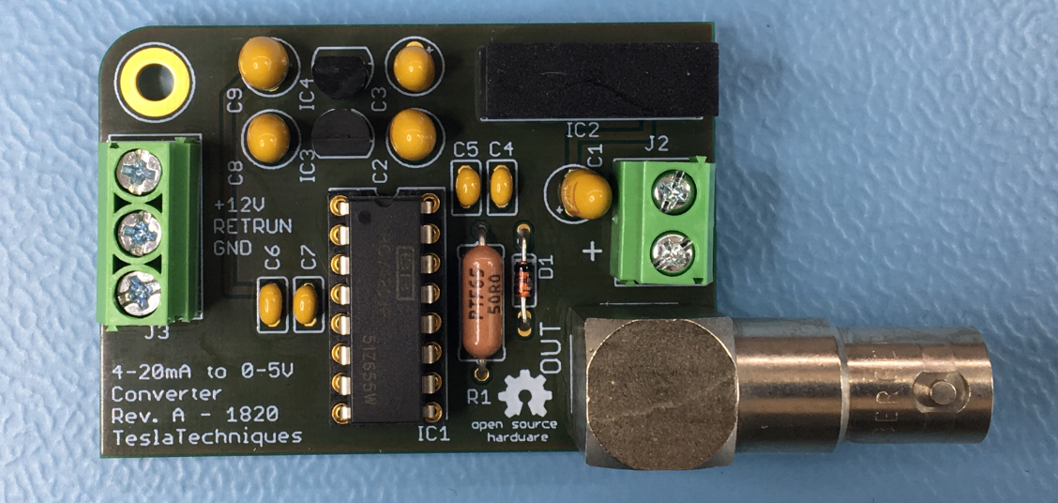

To Scope

Supl. In +

Supl. In -

Input supply voltage : 4,5V to 9V, revers polarity protected

Output voltage to transducer : 12V

**Connection diagramm for 3-wire transducers :**

4-20mA out

Voltage in



GND

To Scope

Supl. In +

Supl. In -

Input supply voltage : 4,5V to 9V, revers polarity protected

Output voltage to transducer : 12V